

Title or Task:

Description:

Files Required
Suitable for Classes: | AIT • Multimedia • Cert II IT • Cert II Bus
Area: | Technology & Enterprise
Teacher: | Mr Peter Faulks

Timeline

Date Due:

Task Brief:

Outcomes:

Items highlighted in yellow are tasks for you to complete
Items in Purple are help tips

Using Fireworks Worksheet

Open Fireworks

Making Flowers in Illustrator
Open a new document A4
Step 1: Set up your document. To begin, launch Illustrator and open a new CMYK or RGB document, whichever you prefer. Then, choose Swatch Libraries from the Window menu and add the following libraries: Earthtones_1, Harmonies_1, and Pastels, as shown in Figure 1. This provides you with basic color schemes from which to choose.
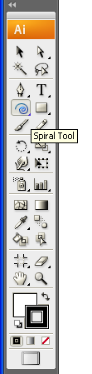
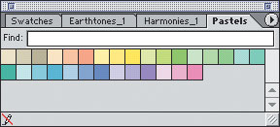
Figure 1
Step 2: Set your spirals. Go to the Toolbox and select the Spiral tool, as demonstrated in Figure 2. Now, using the tool, draw a small spiral on your document, as displayed in Figure 3. Next, go to the Stroke palette and change the spiral's Weight from 1 to 3. Once you've done that, go to one of the Swatches palettes that you opened and select a color for your base stroke. For our example, we went to the Earthtones_1 palette and selected a rich red.
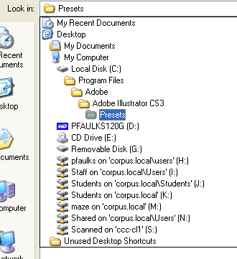

Note: Make sure that your Fill Color is set to none so that your selected stroke colors blend together successfully.

Figure 2
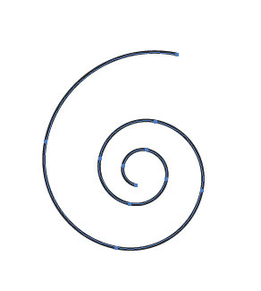
Figure 3
Now, create another spiral, but this time, make it a bit larger. Place the spiral so that it overlaps your original a bit, as shown in Figure 4. Then, select a different color for the Stroke from the same color palette.

Figure 4
Step 3: Fill it in. To fill in the flower with color, select the Blend tool from the Toolbox, as shown in Figure 5. Then, click on the small spiral first and the larger spiral second. This automatically fills in the area between each spiral with a gradient blend, creating a flower as shown in Figure 6.
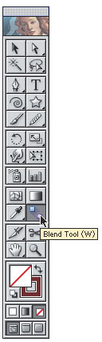
Figure 5

Figure 6
Step 4: Set your arcs. Next, we'll create leaves. To do so, select the Arc tool from the Toolbox. Then, draw one Arc dragging the mouse in an upward motion toward the left of the document. Set the Stroke color to a shade of green. Next, create another arc, but this time drag the mouse down and to the right making the leaf shape shown in Figure 7. Set the Stroke color of this arc to a lighter green or yellow.

Figure 7
Step 5: Blend your arcs. Select the Blend tool from the Toolbox. Click on each arc that you created to fill in your shape, as shown in Figure 8.

Figure 8
Step 6: Put it all together. Make a few copies of your leaf and begin positioning them around the flower. Then, using the Free Transform tool, rotate and resize the leaves, as shown in Figure 9. Select each leaf by using the Selection tool while holding down the [shift] key, and then choose Object > Arrange > Send To Back. Your flower should now resemble that shown in Figure 10.
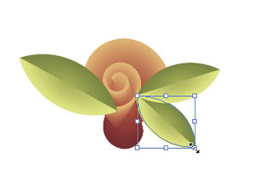
Figure 9

Figure 10
Step 7: Add vines.
To finish up your illustration, you can add in a few green spirals, as shown in Figure 11, to create vines. If you want more control over how your vines look, use the Pencil tool to create them. Then, just smooth out the stroke a bit and your flower is done.

Figure 11

http://www.creativepro.com/article/illustrator-how-to-create-surreal-flowers

. Flower petal
Create two stroke paths: one yellow and one blue.


2. Blend Options
Go to Object > Blend > Blend Options and set it to Specified Steps = 10. Specified Steps basically tells how many step to blend from 1 object to another.
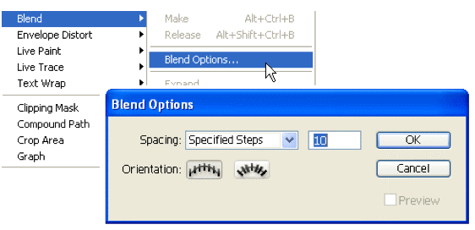

Blend
Now select the 2 petal paths, go to Object > Blend > Make or press Ctrl + Alt + B and you should get something looks like the image shown below.


3. Duplicate more petals
Duplicate more petals to form the flower by Copy & Paste or Alt + Drag.
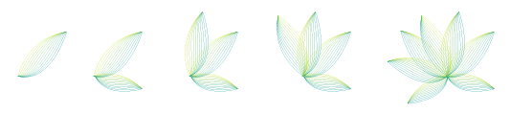

4. Stem
Create a stem by using the same Blend technique as in the previous step. Here I set the Specified Steps = 8.
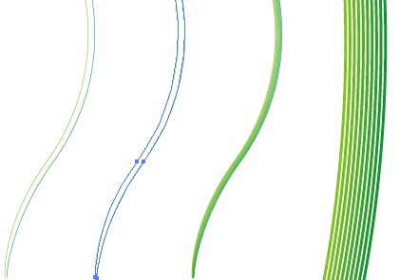

5. Leaf
The leaf is formed by 2 parts, top and bottom. I use Specified Steps = 5 here.


6. Put them together
Now put them together to create a beautiful flower.
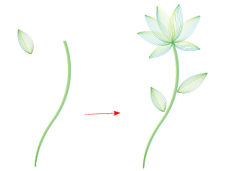

7. Right long leaf
Create a long leaf with Blend step = 3.


8. Left long leaf
Repeat the previous step to create the left long leaf.
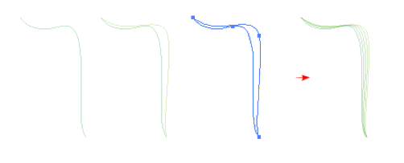

Final
Your final image should looks like the image shown below:
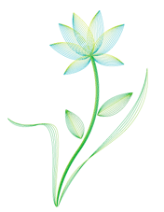

More…
Play around with the stroke color, stroke weight, Blend step, Transparency and you might get unexpected nice result. Here is a sample I did in Photoshop, with different Blend Mode, Multiply and Darken. This image style is good for creating website header, banner, wallpaper, background, large print, etc.


http://www.ndesign-studio.com/resources/tutorials/stylish-vector-flower/

Illustrator Fundamentals: Create a Stylized Flower
Dateline: January 2, 2007
Version: Adobe Illustrator CS2
More Insight articles
There are a number of tools in Illustrator’s tool palette that allow you to develop your own stylized flowers. To create a flower hair clip like the one on the woman in our illustration, you’ll begin by using the Ellipse tool to draw a circle. Next, you’ll use one of Illustrator’s grid tools, the Polar Grid, which uses arcs to produce concentric circles. Then activate the Wrinkle tool to create uneven edges on an object. Select the Free Transform tool to distort the shape of a selected path or series of paths. And, for a final touch, use the Pen tool to draw some leaves.
Launch Illustrator, choose Window > Color (F6). Set the Fill to White and the Stroke to None. Using the Ellipse tool (L), press Shift and drag to create a circle. In our example, we created the flower using an existing illustration.
Double-click the Polar Grid tool. Use the options in the resulting Polar Grid Tool Options dialog box and click OK. Starting from the middle of the already existing circle, press Option + Shift and drag to create a Polar Grid Circle. In the Color palette, set the Fill to None and the Stroke to C:0; M:55; Y:0; K:0.
Double-click the Wrinkle tool. Use the options in the resulting Wrinkle Tool Options dialog box and click OK. Quickly click twice in the middle of the Polar Grid Circle.
Choose Window > Brush Libraries > Artistic_ Watercolor. Choose Watercolor Stroke 4. Set the Stroke weight to .5 pt.
Choose Select > All (Command + A). Using the Selection tool (V), Optionclick the flower and drag to the left to duplicate it. Using the Free Transform tool (E), shift-click the lower left corner of the box and drag to reduce the size of the flower. Change the Stroke to C:0; M:12; Y:90; K:0 (left). Choose Object > Arrange > Send Backward (Command + [ ).
Choose Select > Deselect (Command + Shift + A). Set the Fill and Stroke to C:100; M:0; Y:100; K:0. Using the Pen tool (P), draw leaves around the flowers. Using the Selection tool (V), press Shift and select all the green leaves. In the Artistic_ Watercolor palette, choose Watercolor-Blend (far below, left). Set the Stroke weight to .5 pt. Choose Object > Arrange > Send Backward (Command + [ ).
Our final effect is shown at left.
http://www.graphics.com/modules.php?name=Sections&op=viewarticle&artid=482

